ABES ENGINEERING COLLEGE, GHAZIABAD (AUTONOMOUS)
Mid Term-I (Session: 2025-26)
Max. Marks: 15 Subject Name: Basics of Electronics Engineering Time: 75 Minutes
Subject Code:25EC101 Semester:1

SECTION-A (Maximum Knowledge Level: K2)
1. Attempt All Questions (1 x 5)

Q 1. Barrier potential of a P–N junction diode:
SOLUTION: It is the potential difference developed across the P–N junction due to diffusion of charge carriers, which opposes further carrier movement. Its typical value is ≈0.7 V for Si and ≈0.3 V for Ge diodes. This potential barrier must be overcome for the diode to conduct in the forward direction. It helps in maintaining equilibrium by preventing further diffusion of majority carriers.
Q 2. Peak Inverse Voltage (PIV):
SOLUTION: PIV is the maximum reverse voltage a diode can withstand without undergoing breakdown. For a center-tapped full-wave rectifier, PIV = 2 × Vm, where Vm is the peak secondary voltage per half. If the reverse voltage exceeds the PIV, the diode may get permanently damaged.
Hence, the PIV rating determines the safe operating limit of the diode in rectifier circuits.
Q 3. Ripple factor:
SOLUTION: It is the ratio of the RMS value of the AC component to the DC component in the rectifier output.
- Half-wave rectifier: 𝛾 = 1.21
- Full-wave rectifier: 𝛾 = 0.482
A smaller ripple factor means smoother DC output.
Filters are used to further reduce the ripple in power supply circuits.
Q 4. BJT is bipolar or unipolar?
SOLUTION: BJT is a bipolar device because both electrons and holes take part in the conduction process i.e., conduction starts because of both the polarities (minority & majority as well). In contrast, unipolar devices like FETs use only one type of charge carrier. The involvement of both carriers provides better amplification characteristics. Therefore, BJTs are widely used in analog signal amplification.
Q 5. Why is the size of the collector larger than the emitter?
SOLUTION: The collector is made larger to dissipate more heat and handle higher power and current compared to the emitter. It also helps in reducing the chances of thermal breakdown during operation. Also, the area of Collector is made larger so that it can handle maximum charge carriers.
This structural difference ensures efficient current collection and longer device life.

SECTION-B (Minimum Knowledge Level: K2)
2. Attempt Any two Question (Same K Levels) (2 x 2)
Q 1. Draw the V–I Characteristics of a P–N Junction Diode and Define Breakdown Voltage SOLUTION: A P–N junction diode allows current to flow easily in the forward direction and blocks it in the reverse direction.
- In forward bias, when the applied voltage exceeds the barrier potential (0.7 V for Si, 0.3 V for Ge), the diode conducts and current increases rapidly.
- In reverse bias, only a small leakage current flows due to minority carriers.
As the reverse voltage increases and reaches a certain critical value, called the breakdown voltage (Vz), the reverse current suddenly increases. The breakdown voltage is the reverse voltage at which the diode starts conducting heavily without damage if current is properly limited. This is usually undesirable in most diodes except in specialized ones like Zener diodes designed to operate in breakdown conditions. The current that exists under reverse-bias conditions is called the reverse saturation current. [1 MARK]

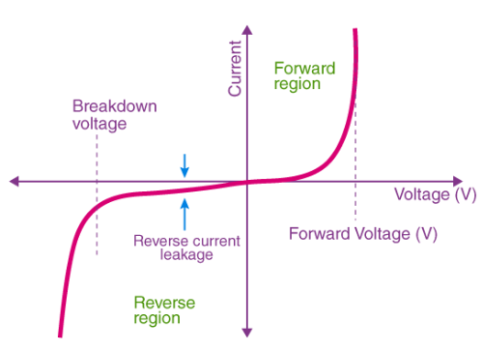
V-T CHARACTERISTICS [1 MARK]

Q 2. Explain the Working of Centre-Tap Transformer Type Full-Wave Rectifier
SOLUTION: A centre-tap full-wave rectifier converts both halves of an AC input into pulsating DC using two diodes and a centre-tapped transformer. Full-wave rectifier circuits are used for producing an output voltage or output current which is purely DC. The main advantage of a full-wave rectifier over half-wave rectifier is that such as the average output voltage is higher in full-wave rectifier, there is less ripple produced in full-wave rectifier when compared to the half-wave rectifier. the unwanted AC component that remains in the DC waveform after converting AC voltage to DC voltage. The transformer’s secondary winding has a centre tap that acts as the common ground. [1 MARK]
- During the positive half cycle, diode D₁ is forward biased as it is connected to the top of the secondary winding while diode D₂ is reverse biased as it is connected to the bottom of the secondary winding. Due to this, diode D₁ will conduct acting as a short circuit and D₂ will not conduct acting as an open circuit
- During the negative half cycle, the diode D₁ is reverse biased and the diode D₂ is forward biased because the top half of the secondary circuit becomes negative and the bottom half of the circuit becomes positive. Thus, in a full wave rectifier, DC voltage is obtained for both positive and negative half cycle.
The Peak Inverse Voltage (PIV) for each diode is 2Vm, and the rectifier efficiency is about 81.2% with a ripple factor of 0.482.
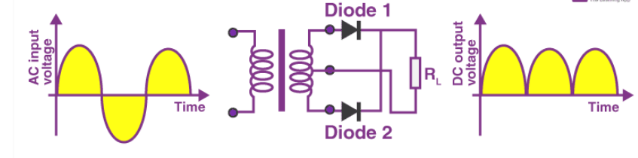
CENTER TAPPED FULL WAVE RECTIFIER [1 MARK]

Q 3. Explain the Application of Zener Diode as a Voltage Regulator
SOLUTION: A Zener diode is designed to operate in the reverse breakdown region to maintain a constant voltage across the load. It is connected in reverse bias across the load with a series resistor (Rs) connected to the input voltage source. When the input voltage increases, the Zener conducts more current, keeping the load voltage constant at the Zener voltage (Vz). When the input voltage decreases, Zener current reduces, but the voltage across the load remains unchanged. [1 MARK]
A voltage regulator is a device that regulates the voltage level. It essentially steps down the input voltage to the desired level and keeps it at that same level during the supply. The voltage regulator is used for two main reasons, and they are:
  - To vary or regulate the output voltage & to keep the output voltage constant at the desired value despite variations in the supply voltage.
  - Zener diode in over-voltage protection, Zener diode is used as for meter protection against damage from accidental application of excessive voltage. [1 MARK]
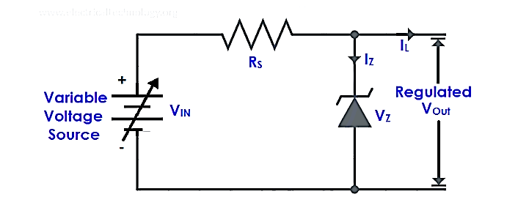
Voc = $\frac{Vi * R_{L}}{R+R_{L}}$
  - If Voc ≥Vz , ZD is ON (Closed switch, replace it with battery)
  - If Voc ≤ Vz , ZD is OFF (Open switch)

